When using a personal firewall, a specific port will need to be opened to allow free access for the license manager to function properly.

- Click on the Search box, by the Windows Start menu.

- Type Control Panel. A list of possible answers will show the Control Panel.
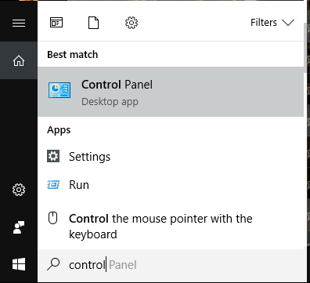
Left-click on Control Panel.

- Click on “View By” option, on the upper, right-hand side of the window.
Select Large icons.
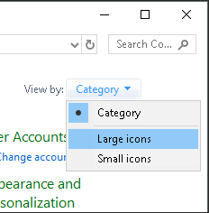
- Browse to, and select, Windows Firewall.
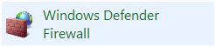

- Click on Advanced settings, on the upper, left-hand side.

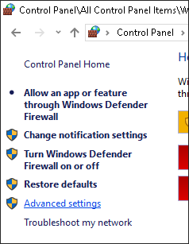

- 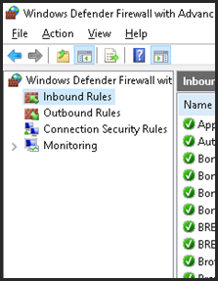Select Inbound Rules, on the upper, left-hand side.

- Next, select New Rule, from the upper, right-hand side.
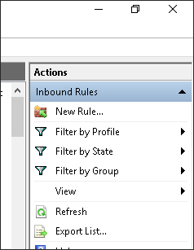

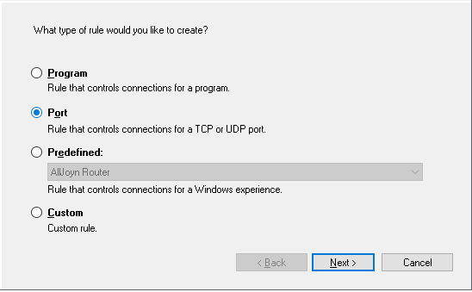
- Select Port, in the Inbound Rule Wizard. Then, click Next.

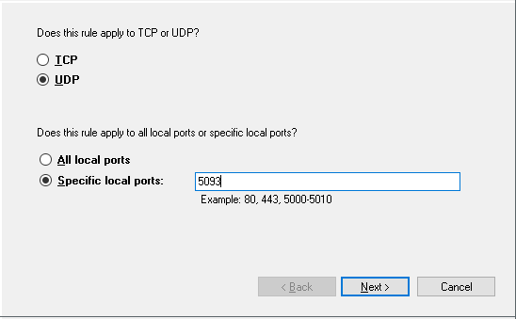
- Select UDP. Enter the port number: 5093. Then, click Next.

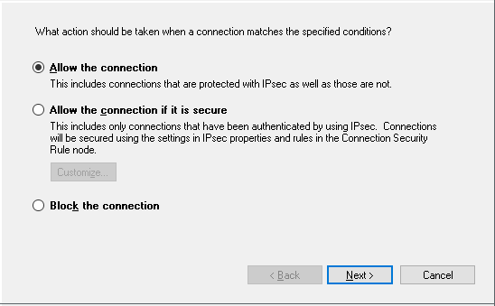
- Allow the Connection. Then, click Next.

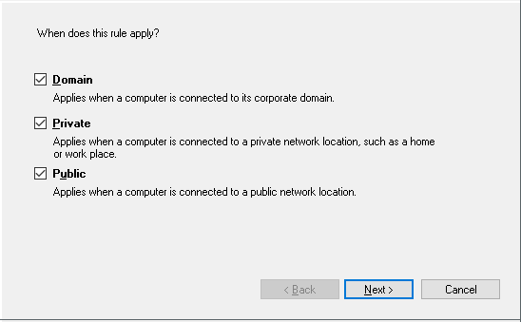
- You may accept the default settings. Then, click Next.

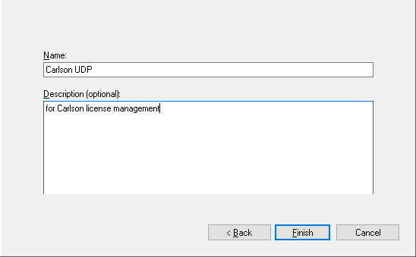
- Enter “Carlson UDP”, as the rule name. You may also enter additional information. Then, click Finish.

You may now close the Windows Firewall settings.

